SIMATS ENGINEERING
ASSESSMENT TOOL 1: Experiments

COURSE NAME: | Cloud Computing and Big Data Analytics | COURSE CODE: | CSA1596

COURSE OUTCOME COVERED
CO3: Implement cloud-based solutions using cloud storage, web APIs, and platform services for real-world applications. (BL3)
Assessment Tool Weightage: 40%

Dave's Taxonomy: Precision (Level 3)  Question Count: 4 | Total Marks: 40
Duration : 60 Minutes
Code of Conduct
I f.fathima shafreena(192511381) certify that this submission is my original work and that I have adhered to the guidelines specified for this assessment.
I understand that any violation of academic integrity rules will result in disciplinary action.
Signature of the student:

Experiments Rubric
Criteria | Weightage | Level 4 - Exemplary | Level 3 - Proficient | Level 2 - Developing | Level 1 - Beginning
Experimental Design | 25% | Design is systematic and technically strong | Mostly correct design | Basic design with gaps | Poorly designed activity
Use of Tools / Platforms | 20% | Appropriate and effective use of cloud tools | Good tool usage with minor issues | Limited tool usage | Incorrect or missing tool usage
Application of Concepts | 20% | Concepts are applied accurately to practical tasks | Mostly accurate application | Partial application | Weak application
Analysis and Output | 20% | Strong analysis and meaningful outcome interpretation | Good analysis with minor gaps | Basic analysis | Little or no analysis
Documentation | 15% | Clear, structured, and complete documentation | Mostly complete documentation | Partially complete | Poor documentation

Total Marks Awarded:

Assessment Tasks-2

Experiments

Experiment 1:
Create a simple cloud software application for Hospital information system for SIMATS Hospital using any Cloud Service Provider to demonstrate SaaS with fields of patient name, age, address, phone, email, Attender name, attender phone, doctor name, diseases, etc.

AIM:

To create a simple cloud-based Hospital Information System for SIMATS Hospital using a Cloud Service Provider to demonstrate Software as a Service (SaaS) with patient and hospital management details.
Procedure
- Log in to the cloud platform (Zoho Creator).
- Create a new application named SIMATS Hospital Information System.
- Create a patient registration form.
- Add the required fields:
  - Patient Name
  - Age
  - Address
  - Phone Number
  - Email
  - Attender Name
  - Attender Phone
  - Doctor Name
  - Disease
- Save the form and publish the application.
- Enter sample patient details and verify that the data is stored successfully in the cloud database.
- Test the application by adding, editing, and viewing patient records.

1.1 Patient details
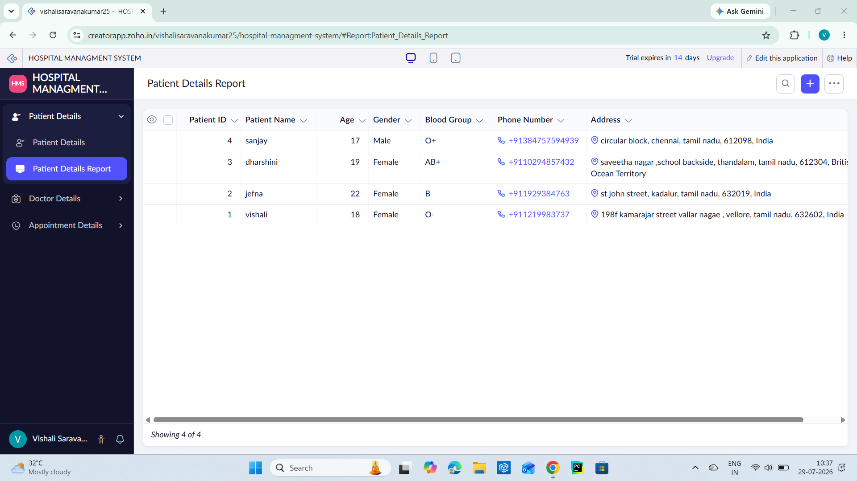

1.2 doctor details
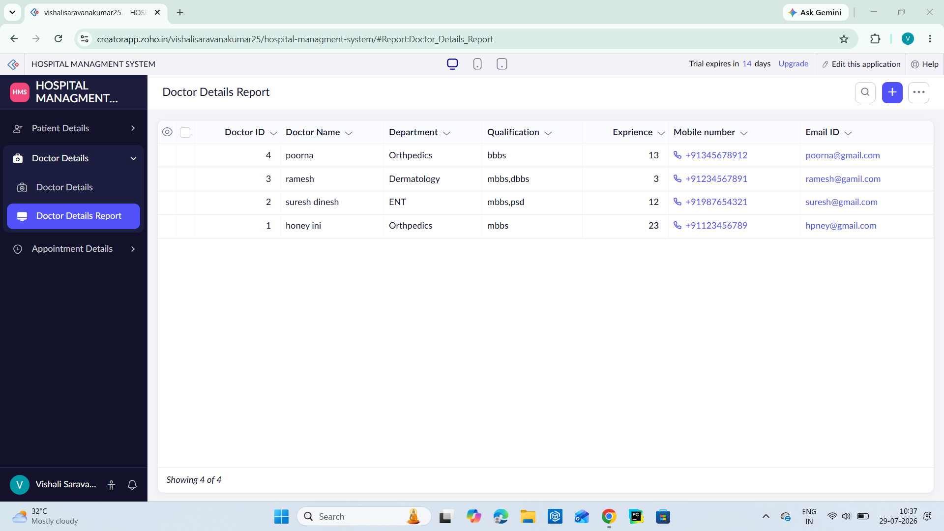
1.3 appointment details

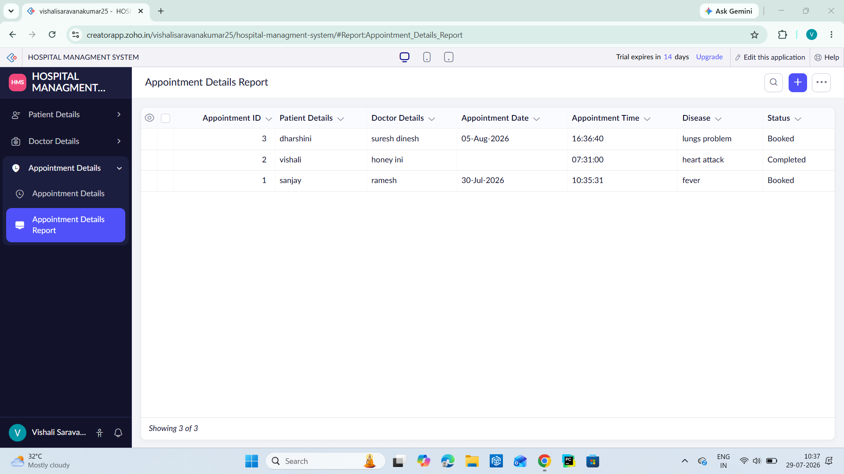

- Result
A cloud-based Hospital Information System was successfully created using a Cloud Service Provider to demonstrate the SaaS model. The application allows users to store and manage hospital and patient information online.

Experiment 2: Create a simple cloud software application for online super market using any Cloud Service Provider to demonstrate SaaS with the template of customer name, address, phone, email, items, quantity etc. with the item classification form.

Aim
To create a simple cloud-based Online Supermarket application using a Cloud Service Provider to demonstrate Software as a Service (SaaS) with customer details, item details, quantity, and item classification.
Procedure
- Log in to the cloud platform (Zoho Creator).
- Create a new application named Online Supermarket System.
- Create a customer order form.
- Add the required fields:
- Customer Name
- Address
- Phone Number
- Email
- Item Name
- Quantity
- Item Classification
- Save the application and publish it.
- Enter sample customer and product details.
- Verify that the order details are stored and can be viewed or edited through the cloud application.
2.1 customer managment
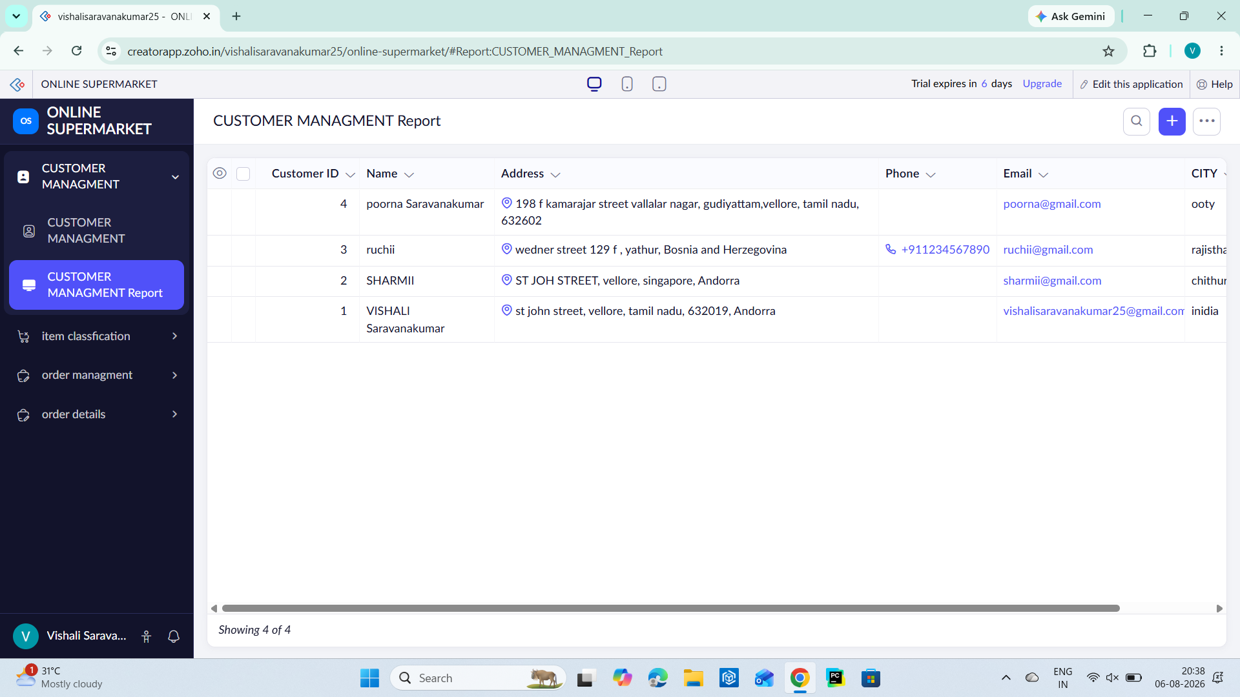
2.2 customer management

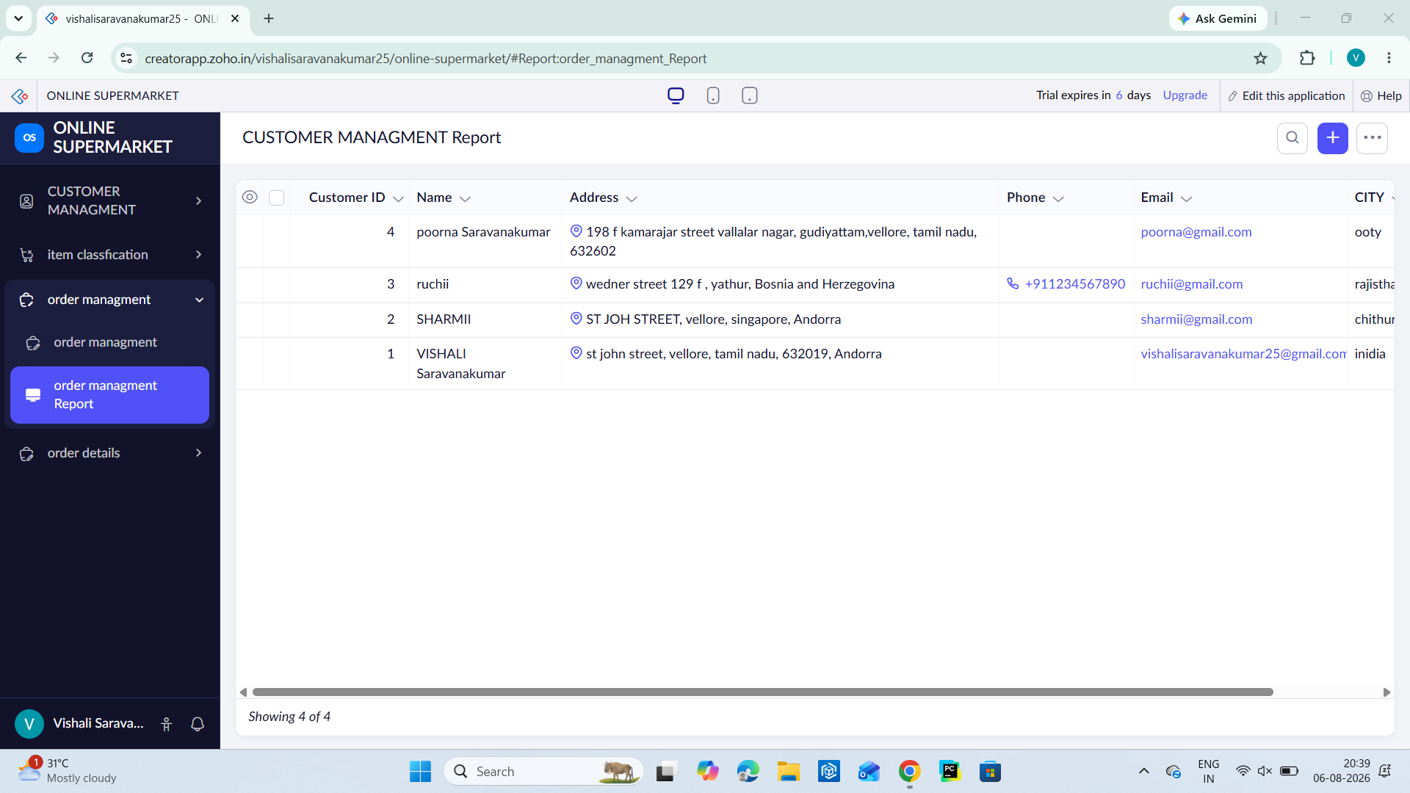

2.3 customer management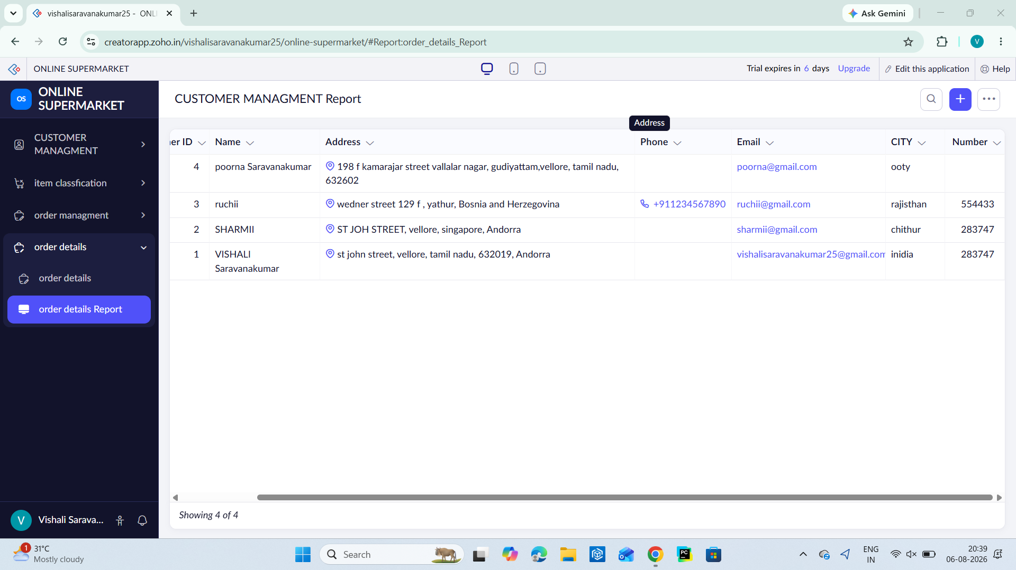

Result
A cloud-based Online Supermarket application was successfully developed using a Cloud Service Provider to demonstrate the SaaS model. The application enables online storage and management of customer and product information.
These write-ups are concise and suitable for a practical record, matching the style typically expected in cloud computing laboratory experiments.
Experiment 3: Demonstrate virtualization by Installing Type-2 Hypervisor in your device, create and configure VM image with a Host Operating system (Either Windows/Linux). Create a Virtual Machine with 3 CPU, 10GB RAM and 10GB storage disk using a Type 2 Virtualization Software.

Aim
To demonstrate virtualization by installing a Type-2 Hypervisor, creating and configuring a virtual machine with 3 CPU cores, 10 GB RAM, and 10 GB virtual storage using Oracle VirtualBox.
Procedure
- Download and install Oracle VirtualBox on the host operating system.
- Download the Ubuntu Linux ISO image.
- Open VirtualBox and create a new virtual machine.
- Select Linux as the operating system.
- Allocate 10 GB (10240 MB) RAM.
- Assign 3 CPU cores to the virtual machine.
- Create a 10 GB virtual hard disk.
- Attach the Ubuntu ISO file to the virtual machine.
- Start the virtual machine and install Ubuntu Linux.
- Verify that the virtual machine boots successfully.
Output:
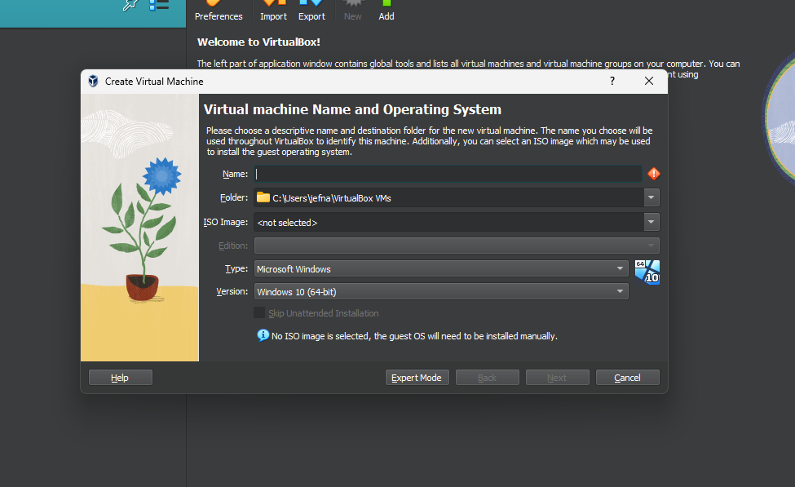

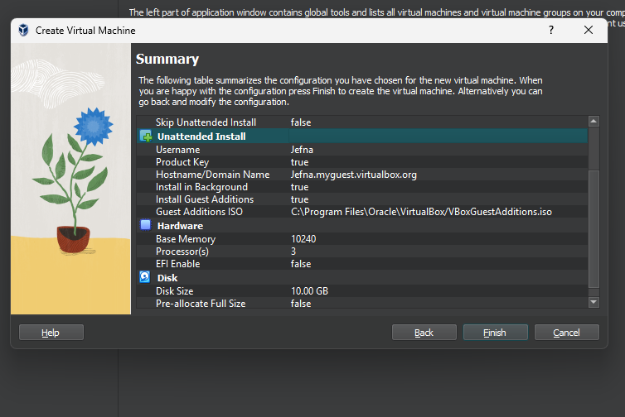
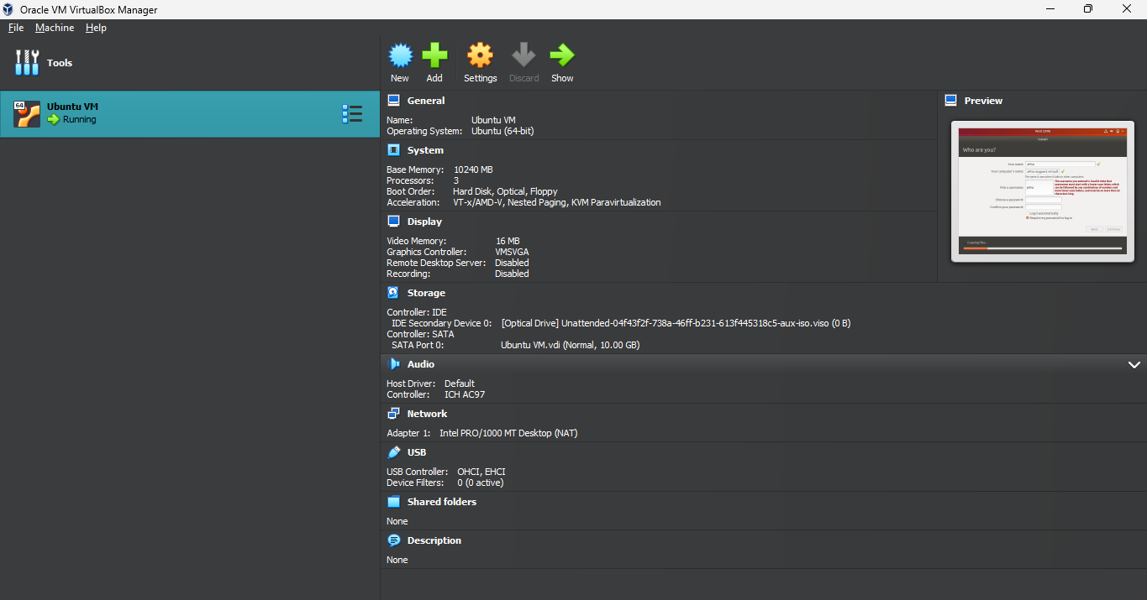


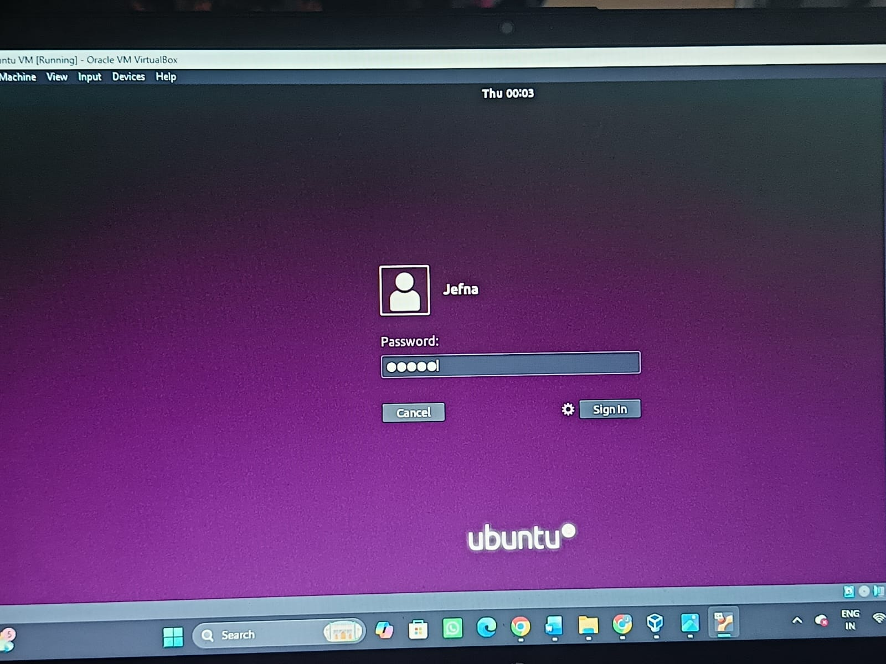
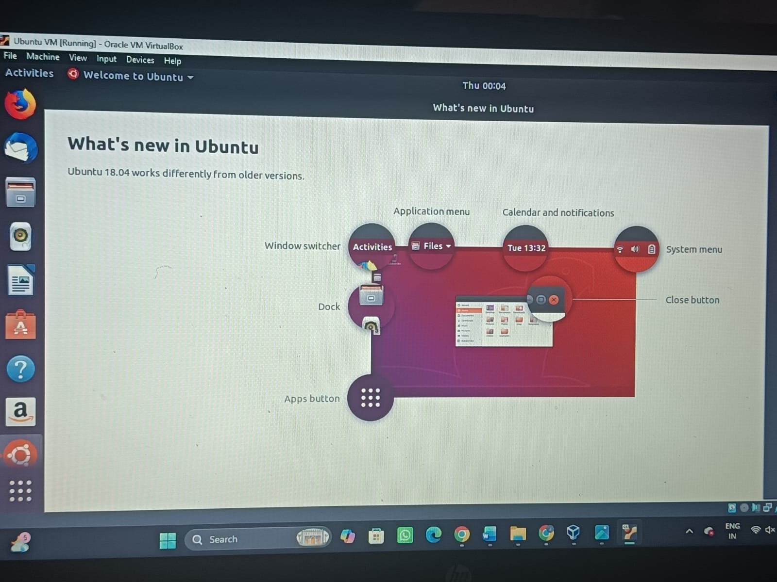

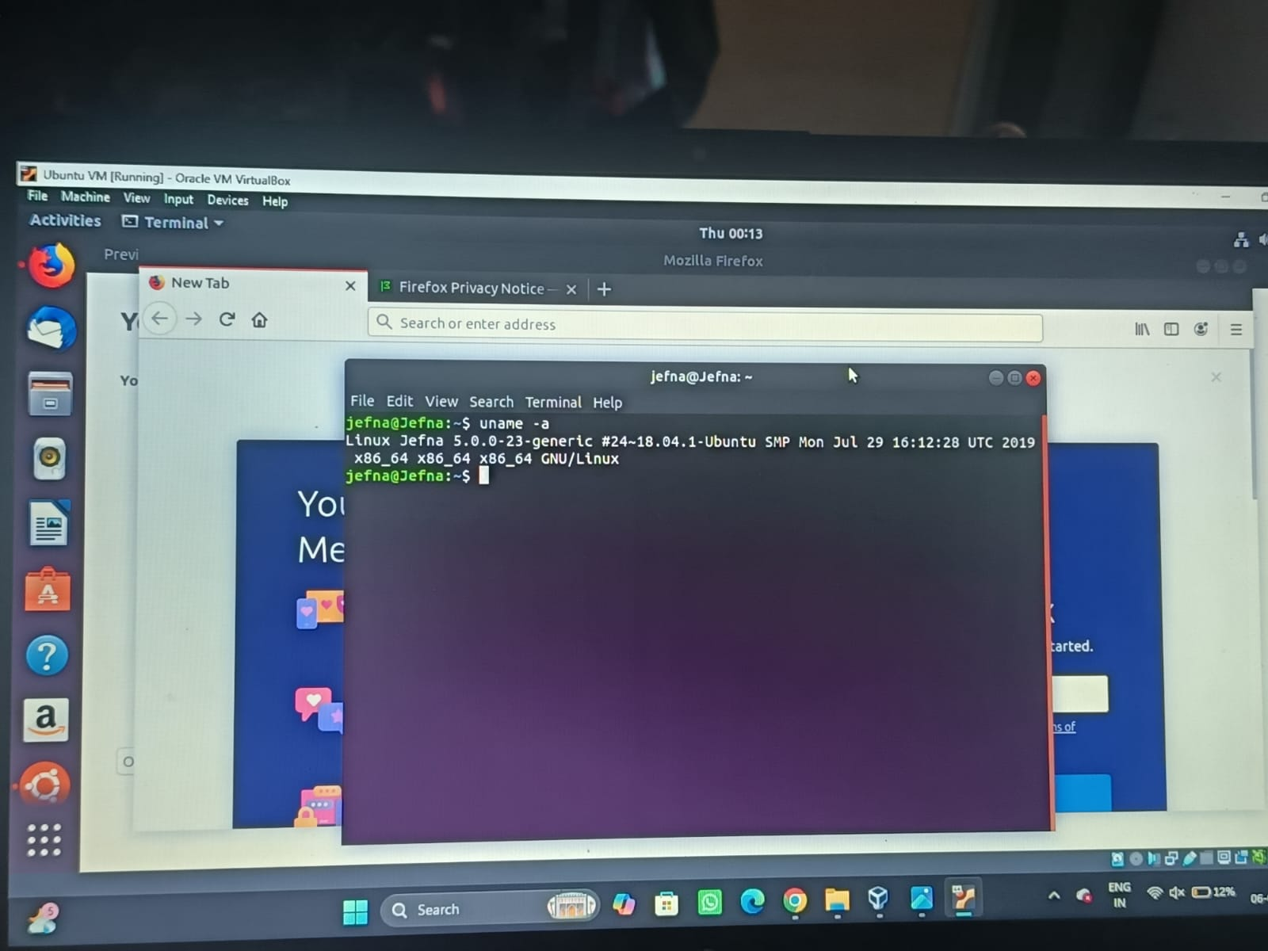

Result
Thus, Type-2 virtualization was successfully demonstrated by installing Oracle VirtualBox on the host operating system. A virtual machine was created and configured with 3 CPU cores, 10 GB RAM, and a 10 GB virtual hard disk, and the Ubuntu Linux operating system was installed successfully. Hence, the virtual machine was created and executed successfully.

Experiment 4: Demonstrate virtualization by Installing Type-2 Hypervisor in your device, create and configure VM image with a Host Operating system (Either Windows/Linux). Create a Snapshot of a VM and Test it by loading the Previous Version/Cloned VM.
Aim
Clone your existing Ubuntu Virtual Machine and prove that the cloned VM works.
Procedure
- Open Oracle VM VirtualBox on the host operating system.
- Ensure the existing virtual machine (Ubuntu VM) is in the Powered Off state.
- Select the Ubuntu VM from the left panel.
- Click Machine → Clone (or right-click the VM and select Clone).
- Enter a name for the cloned virtual machine (e.g., Ubuntu Clone).
- Click Next and choose Full Clone as the cloning type.
- Keep the default MAC Address Policy and click Finish.
- Wait until the cloning process is completed successfully.
- Verify that the cloned virtual machine appears in the VirtualBox Manager.
- Select the Ubuntu Clone and click Start.
- Wait for the cloned VM to boot and verify that the operating system loads successfully.
- Shut down the cloned virtual machine after testing.

Output:
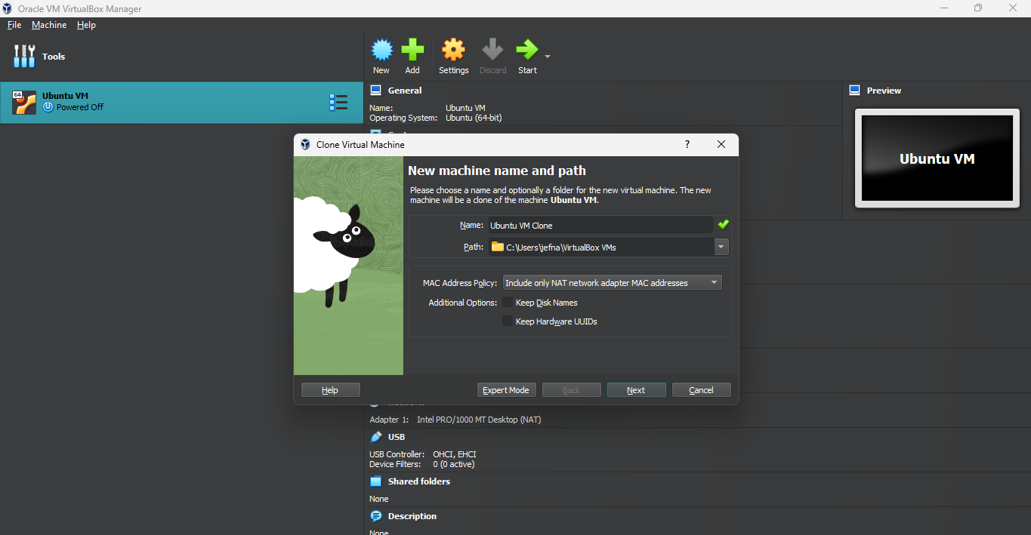
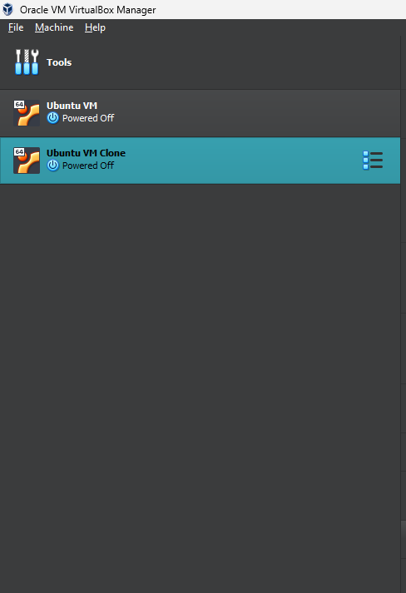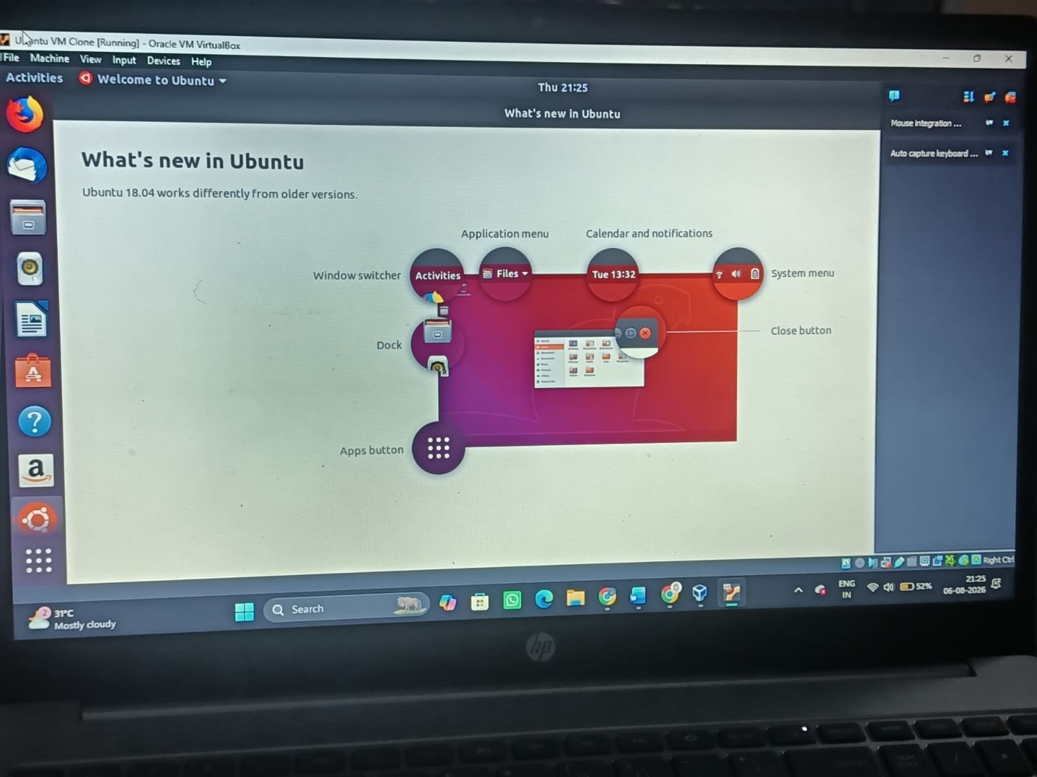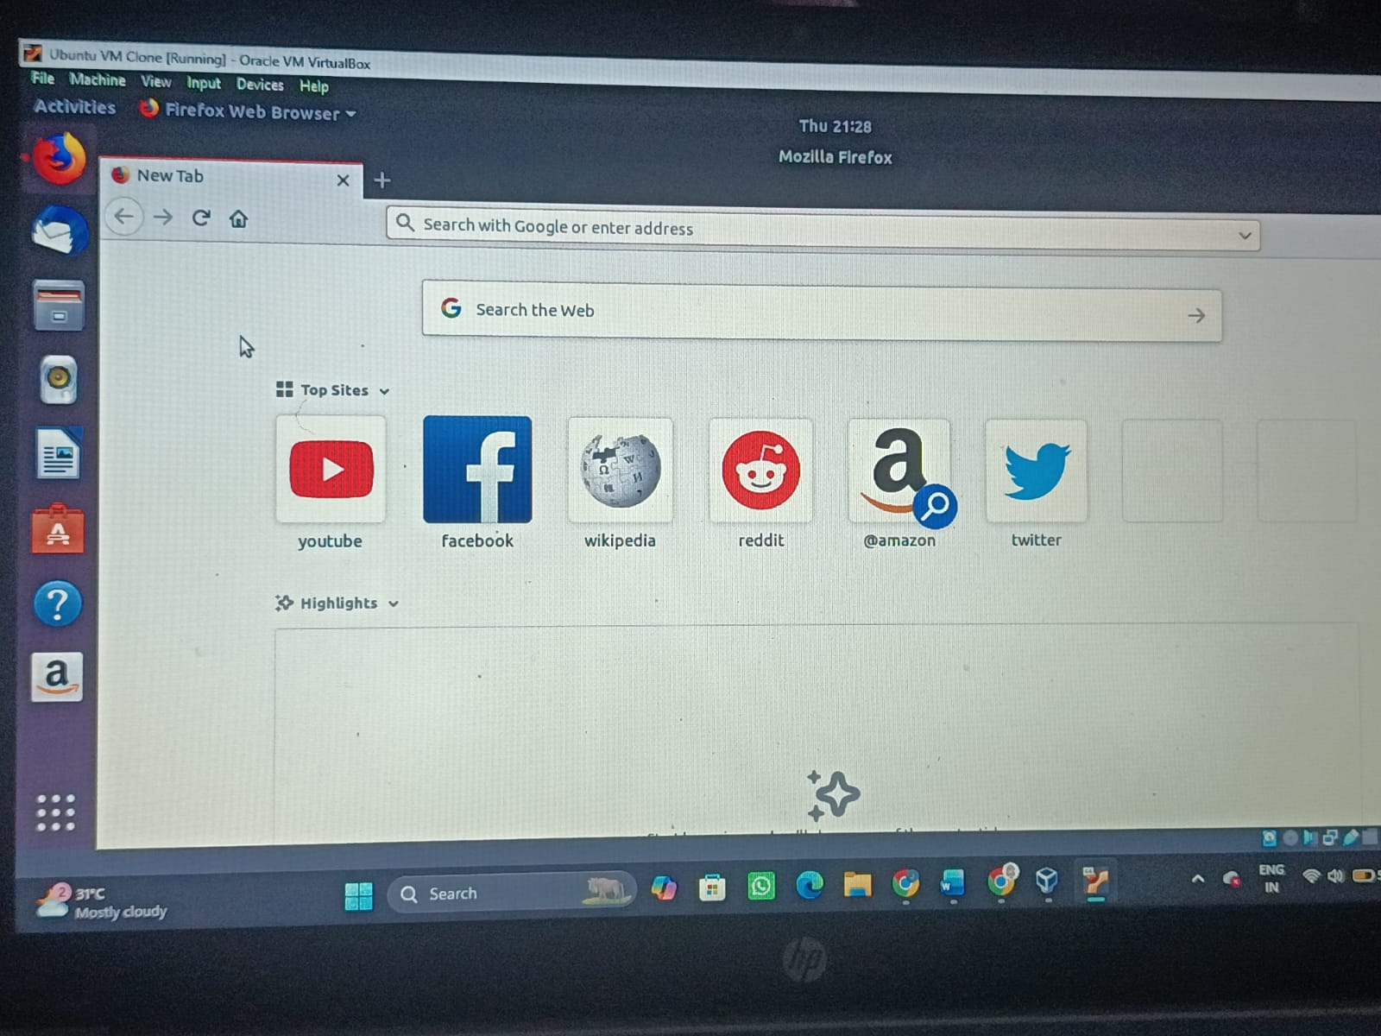

Result
The virtual machine was successfully cloned using Oracle VM VirtualBox, and the cloned VM was tested successfully by booting into the Ubuntu operating system.

